Can we measure the rainfall correctly? A new experiment at the Newton Rigg, DTC site.

Paul Quinn¹, Mark Wilkinson¹ and Michael Pollock¹ and Mark Dutton²

- Newcastle University School of Civil Engineering and Geosciences
- Environmental Measurements Limited

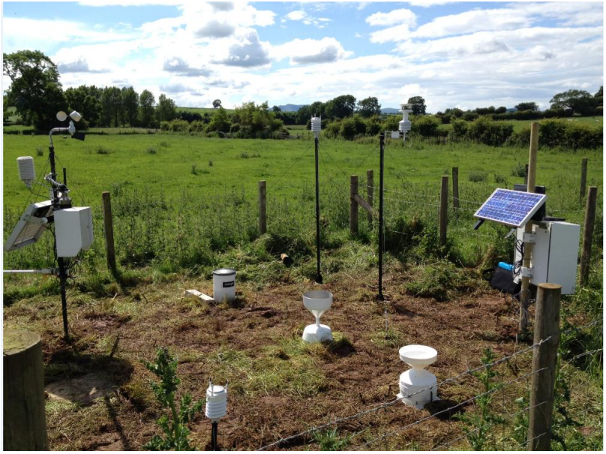
1 2 3 4 5 6 7 8
Figure 1: The equipment installed at Newton Rigg on July 5th 2012. .

List of Equipment moving from left to right:-
- DTC weather station (all weather parameters including a 2m wind speed gauge)
- Ground level WXT520, weather disdrometer, wind speed and rainfall intensity)
- Casella rain gauge (intensity)
- SBS aerodynamic rain gauge
- 2m level WXT520, weather disdrometer, wind speed and rainfall intensity)
- A 2m ultrasonic wind speed gauge
- ARG100 rain gauge
- Logging and telemetry

Building upon the DTC Eden Platform, the Newton Rigg Demonstration Site has been chosen as a site to investigate undercatch from typical rain gauges used in scientific studies and by the water industry. The inter-comparison experiment will run for at least 1 year and aims to highlight the undercatch issue and address the uncertainty in one of the prime inputs to our studies. The experiment follows similar work started in the CHASM experiment taking place in the Upper Eden (see http://research.ncl.ac.uk/proactive/raingaugeundercatch/).
What is the problem?

Scientists/hydrologists/people completely underestimate the problem of wind-induced undercatch and the effect it has on the total catch of rain gauges. There is a false assumption that a “can-type”, simple bucket measuring device will be adequate. This is untrue.

- It is vitally important to measure precipitation events accurately in the UK:
- Hazards mitigation e.g. Real time flood risk by improving accuracy in extreme events.
- Agriculture and pollution
- Water resources (e.g. managing droughts and estimating groundwater recharge)
- Climate studies
- Modelling and Forecasting – ‘rubbish in gives rubbish out’

- Inaccuracies in ground-based point precipitation measurements are propagated with the use of statistical interpolation techniques (e.g. Kriging / Thiessen). This underlines importance of accuracy.

- Aerodynamic shape of the gauge is highly significant. A more aerodynamic rain gauge records more catch – we have a very high confidence in this. I.e. SBS and ARG 100 collect more rain than the Casella gauge. Figure 2, shows the accumulated rain gauge total for the new aerodynamic SBS gauge and the Casella gauge. Please note that all the rain gauges are still under catching.

- New instrumentation (e.g. WXT 520 impact disdrometer) can play a vital role in the development of accurate measurements. The weather transmitter appears to collect more rain in higher wind speeds than TBRs (see Figure 3, point B), but other aspects may still benefit from technical improvements e.g. rainfall collection at low intensities is questioned (see figure 3, Point A).

- Existing evaluations of implications of wind-induced loss from UK literature is sparse:

- In some of the UK’s wetter catchments (Eden), the estimated percentage undercatch by standard rain gauges is approximately equal to the annual average evaporative loss (Hannaford and Marsh, 2008).
- Rodda and Smith (1986) showed that volumes of rain are systematically underestimated at sites across the UK by between 5 and 20%, with underestimates being more serious at sites in wetter parts of the country (in the Upper Eden this could be 20-30%).

- Correction procedures for wind-induced undercatch

- The most accurate methods of correction are applied at the highest temporal scale, with high resolution input variables (wind speed at gauge height, rainfall intensity and drop size distribution).
- Bias corrected climatologies exist for northern latitudes do exist e.g. Siberia, China, Canada, Greenland, Mongolia. Each country has a unique national standard gauge which affects the wind-induced undercatch differently.
- The UK has no similar bias corrected climatology. This will hopefully change as the need for more accurate estimation of the input to the UK’s water resources becomes more pressing. Many studies (e.g. Burt and Ferranti, 2012, Mayes et al., 1996) do not apply corrections to the measured data.
- The WMO have carried out wide ranging test for undercatch issues and have suggested correction. However, we conclude that high resolution analysis of new rain gauges methodologies are needed in the UK.

Thus, there is great potential to use the WXT 520 disdrometer technology to measure wind speed, drop size distribution and rainfall intensity. It would be ideal to correct the intensity values in real time or give realistic error estimates. This issue needs to be brought to the attention of scintists and practitioners. The implications of the uncertainty in estimates must be considered in future planning and studies.

There is still a question as to what is the real rainfall intensity? We are proposing need to add a pit rain gauge to the Newton Rigg to help address this issue (if we have the space).

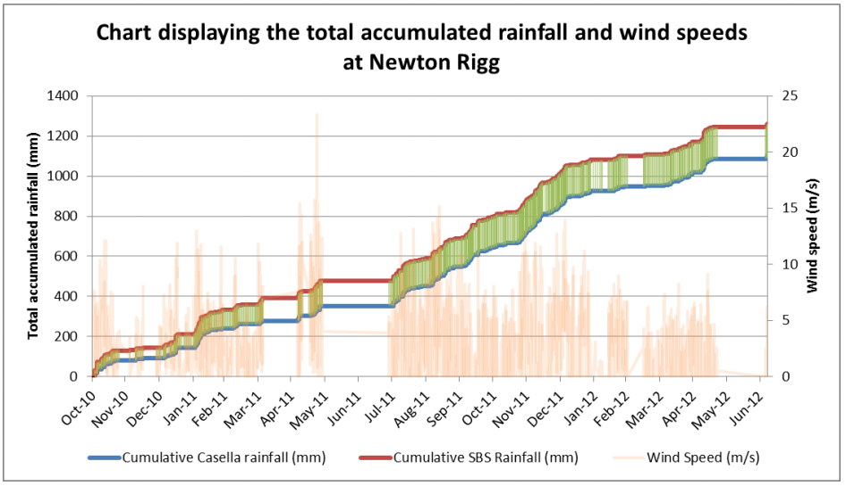

Figure 2: Total accumulated rainfall collected by each tipping bucket rain gauge at Newton Rigg.
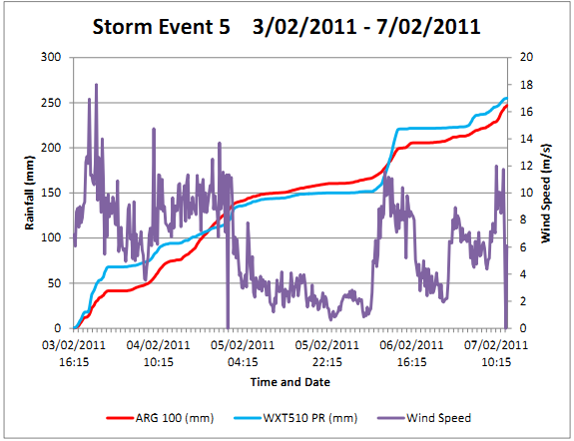
Figure 3: A typical Storm data series observed at Gais Gill (Upper Eden) at the event scale

A: WXT 510 weather transmitter is not recording rainfall whereas the ARG 100 TBR is. Wind speeds are low (less than 4 m/s) and rainfall intensity is also low.
B: WXT 510 weather transmitter capturing more rainfall than the ARG 100 during a higher intensity portion of the storm, occurring in high wind speeds (over 8m/s).

